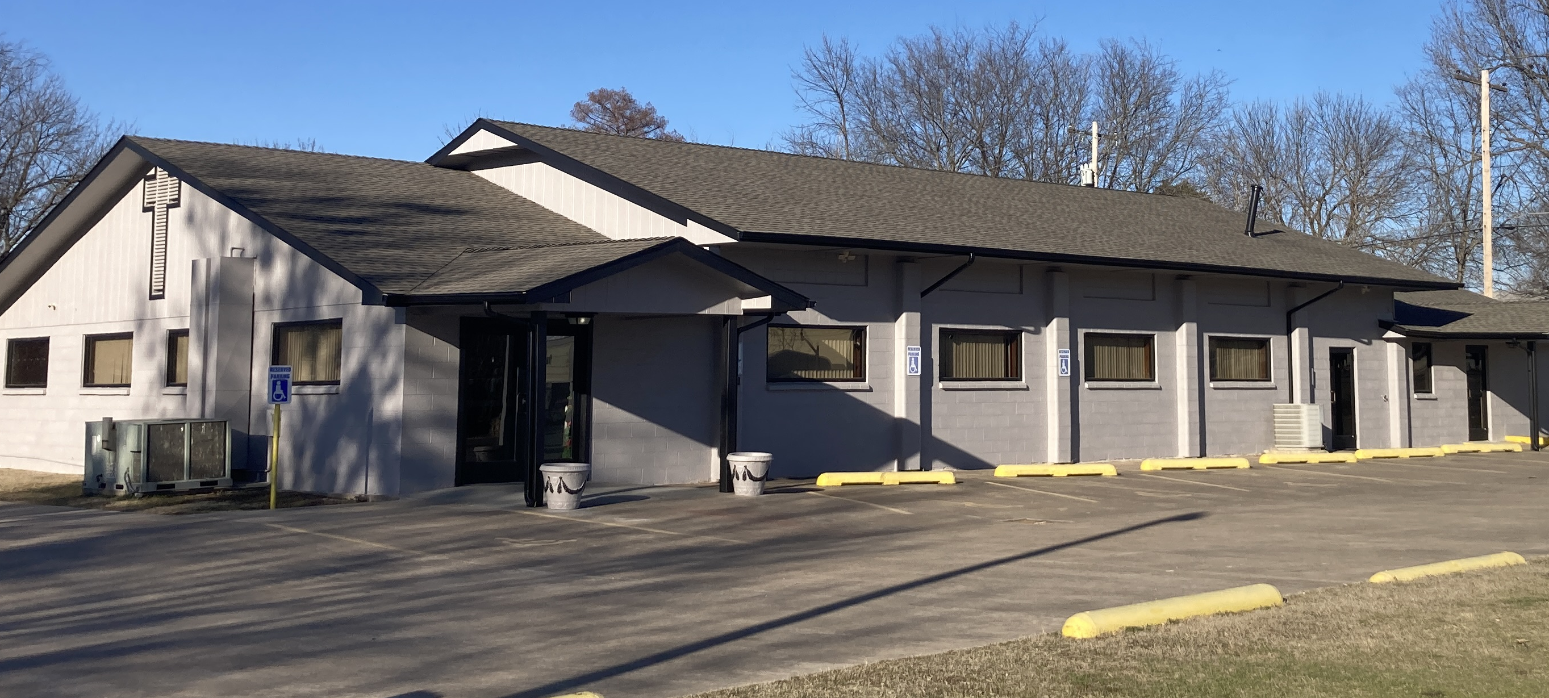
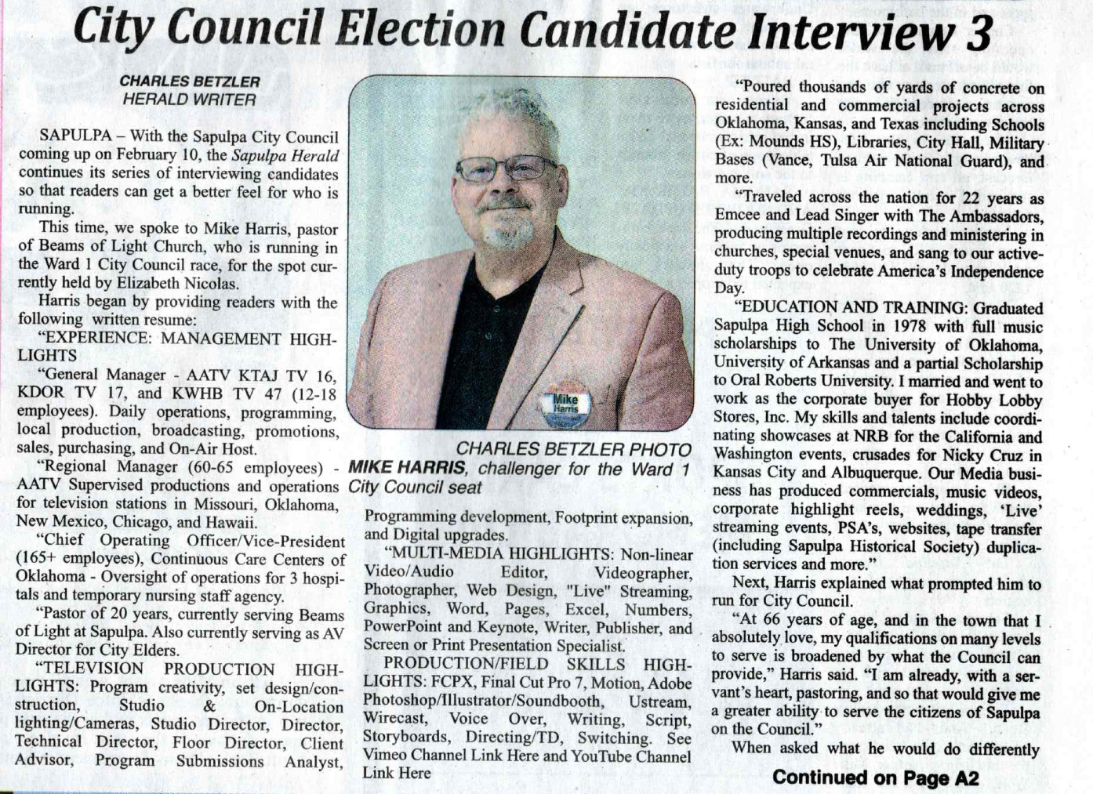
Mike and his wife Lori Pastor the Beams of Light Church on the corner of Murphy Ave and Water Street.

BeamsofLightatSapulpa.com

Today’s news

Interview with The Sapulpa Herald
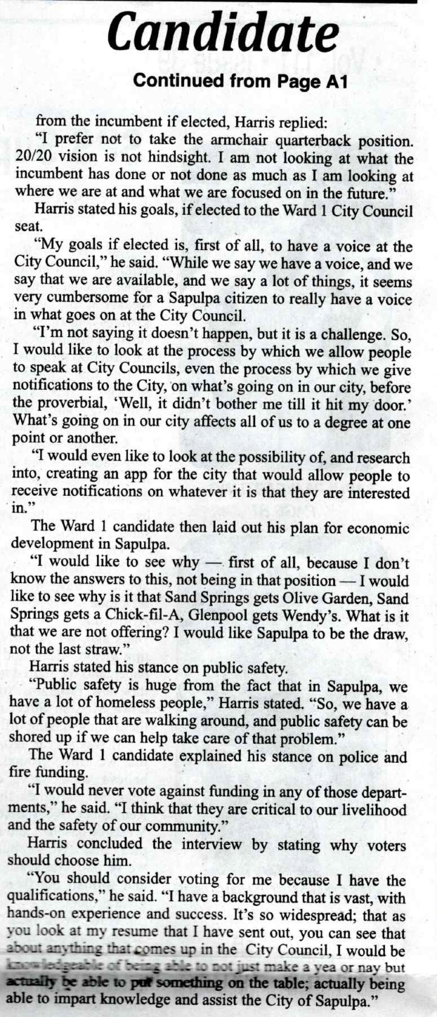
No pretense but common sense!
Being real, neighborly and one that is already lending a hand. Our City is worth taking greater and the only way to do that is TOGETHER.

True Leadership, accountability and transparency…

Mike is QUALIFIED on many levels to serve the City Council of Sapulpa well.

-Source

